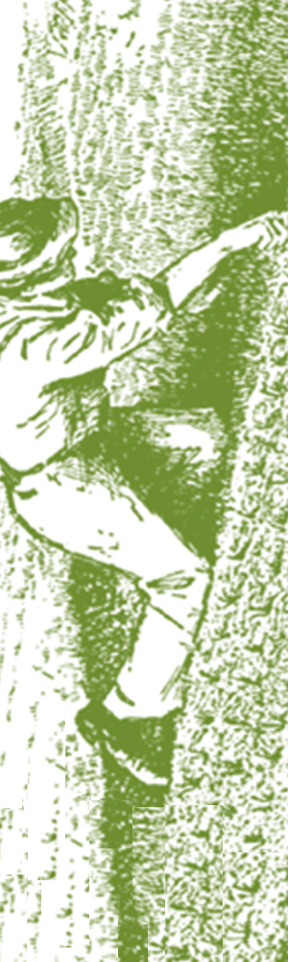**Requirements for Selling Cottage Foods**

Cottage Foods are non-potentially hazardous foods items produced in a person's home such as bakery products, candy, fruit butter, jams, and jellies. In order to meet requirements of the Arkansas Department of Health, cottage food items sold at SWAFMC Farmers’ Markets must meet the following requirements:

* **Labeling**: Each cottage food item must be clearly labeled and make no nutritional claims. The label on each food item shall include the name and address of the manufacturer, the name of the product, the ingredients in the product, and state in 10-point type, “This Product is Home-Produced”. See any of the Market Managers if you need help with labels.
* **Not Allowed**: Food items that must be kept refrigerated or hot to remain safe are not allowed to be sold as Cottage Foods. Example of items not allowed are cheesecakes, Tres Leches cakes, cream or cheese filled items, cream pies, meringue pies, custard pies, pies or bakery items containing meat, and cream cheese based frostings or fillings.

Phone number not *required*.

**If the food item is not a bakery product, candy, fruit butter, jam, or jelly, it cannot be sold as a cottage food item.**

**Requirements for Selling Cottage Foods**

**at SWAFMC Farmers' Markets**

Cottage Foods are non-potentially hazardous foods items produced in a person's home such as bakery products, candy, fruit butter, jams, and jellies. In order to meet requirements of the Arkansas Department of Health, cottage food items sold at SWAFMC Farmers’ Markets must meet the following requirements:

* **Labeling**: Each cottage food item must be clearly labeled and make no nutritional claims. The label on each food item shall include the name and address of the manufacturer, the name of the product, the ingredients in the product, and state in 10-point type, “This Product is Home-Produced”. See any of the Market Managers if you need help with labels.
* **Not Allowed**: Food items that must be kept refrigerated or hot to remain safe are not allowed to be sold as Cottage Foods. Example of items not allowed are cheesecakes, Tres Leches cakes, cream or cheese filled items, cream pies, meringue pies, custard pies, pies or bakery items containing meat, and cream cheese based frostings or fillings.

Phone number not *required*.

**If the food item is not a bakery product, candy, fruit butter, jam, or jelly, it cannot be sold as a cottage food item.**

**Farmer’s Market Quick Reference**

**Permit Required to Sell:**

Anything requiring handling, bagging, dividing, portioning, weighing, etc

Anything requiring refrigeration

Canned foods

Cheesecake

Cream Cheese based Frosting or Filling

Cream Pies and Cream Filled Items

Cured Meats

Custard Pies

Dried Fruit/Vegetables/Herbs/Spices

Dried Meats

Juices

Meringue Pies

Milled Grain/Flour/Meal

Pickled Vegetables

Salad

Shelled Peas or Nuts

Sliced Fruit or Vegetables

Smoked Meats

Sprouted Beans

Sprouted Seeds

Salsa

**No Permit Required to Sell:**

Bakery Products

Brownies (Containing legal ingredients)*

Cakes without cream icing

Candy

Cookies

Farm Fresh Eggs*

Frozen Meat (USDA inspected)*

Fruit Butter

Honey

Jam

Jelly

Maple Syrup

Sorghum

Whole, Uncut Fruits/Vegetables Commercially Processed Non-Potentially Hazardous Food

**\*Conditions apply - For additional clarification contact the Environmental Health Specialists located in the County Health Unit.**

**Prohibited from Sell:** Homemade Cheeses

Raw Milk

Wild Harvested Mushrooms

**Farmer’s Market Quick Reference**

**Permit Required to Sell:**

Anything requiring handling, bagging, dividing, portioning, weighing, etc

Anything requiring refrigeration

Canned foods

Cheesecake

Cream Cheese based Frosting or Filling

Cream Pies and Cream Filled Items

Cured Meats

Custard Pies

Dried Fruit/Vegetables/Herbs/Spices

Dried Meats

Juices

Meringue Pies

Milled Grain/Flour/Meal

Pickled Vegetables

Salad

Shelled Peas or Nuts

Sliced Fruit or Vegetables

Smoked Meats

Sprouted Beans

Sprouted Seeds

Salsa

**No Permit Required to Sell:**

Bakery Products

Brownies (Containing legal ingredients)*

Cakes without cream icing

Candy

Cookies

Farm Fresh Eggs*

Frozen Meat (USDA inspected)*

Fruit Butter

Honey

Jam

Jelly

Maple Syrup

Sorghum

Whole, Uncut Fruits/Vegetables Commercially Processed Non-Potentially Hazardous Food

**\*Conditions apply - For additional clarification contact the Environmental Health Specialists located in the County Health Unit.**

**Prohibited from Sell:** Homemade Cheeses

Raw Milk

Wild Harvested Mushrooms